TALIBON POLYTECHNIC COLLEGE
BED 106 — BUSINESS ANALYTICS
Mini Business Analytics Capstone Project — Checkpoint 4 (Final)
LIBRARY ANALYTICS:
Book Borrowing Trends and Student Reading Behavior
Final Integrated Capstone Report
Group 1 — The Data Bookworms
Table 1. Team members and roles
Member | Role
Peter Paul Polestico | Project Lead / Analyst
Ken T. Lubrico | Data Engineer
Johnro Balingit | Statistician / Modeler and BI Developer / Visualizer

Course: BED 106 — Business Analytics (3 Units)
Instructor: Jessie A. Melendres
Academic Year 2026–2027, 1st Semester
Date Submitted: October 22, 2026

Table of Contents
1. Title Page
2. Executive Summary
3. Business Problem and Data Source
4. Database Design and SQL Analysis
5. Statistical Analysis
6. BI Dashboard Summary
7. Predictive Analytics
8. Ethics and Governance
9. Conclusions and Recommendations
10. References
11. Appendix

2. Executive Summary
Problem. The academic library has no data-driven view of who uses its collection, which books earn real engagement, and whether recommendations serve new (“cold-start”) patrons as well as established ones. We analyzed 12,000 patron–book interaction events (Academic Digital Library Book Recommendation Dataset, Kaggle) to answer three questions: which patron types and departments borrow irregularly, which categories and formats drive engagement, and whether cold-start patrons are underserved.
Methods. SQL (CP1), Excel statistics and regression (CP2), Power BI dashboard with K-Means segmentation (CP3), and multiple and logistic regression with an ethics review (CP4).
Key findings.
- New patrons get weaker recommendations. Cold-start patrons (18.5% of events) search and read as much as others, yet score 0.478 versus 0.574.
- The cause is thin borrowing history, not the label. In the multiple regression (R² = 0.91 on unseen data), borrowing frequency is the top predictor and the cold-start flag adds nothing (p = 0.81).
- Irregular borrowing is library-wide. About 16.1% of events are flagged; Medicine (17.1%) is highest, but department differences are not statistically significant (p = 0.81).
- Four patron segments emerged; Casual / At-Risk Patrons score lowest (0.478).
Recommendations. Build a fast-start onboarding path for new patrons; send segment-specific nudges; run irregular-borrowing reminders library-wide; improve book metadata and patron interest profiles; and use the classifier (94.6% accuracy) as an early-warning list.
Caveat. The data are synthetic and the recommendation score is itself an algorithm's output, so results describe how this system behaves in the data and should be validated on real circulation records.

3. Business Problem and Data Source

3.1 Business Domain and Problem
Domain: Education Analytics — Academic Digital Library Services. Problem: the library cannot currently see how undergraduates, postgraduates, faculty and research scholars actually borrow and engage with its collection, which categories and formats earn real engagement, or whether the discovery and recommendation experience works as well for new patrons as for established ones. Acquisition budgets and recommendation features only pay off when they match real behavior, so the library needs evidence to decide where to invest in onboarding, outreach and collection development.

3.2 Key Business Questions
- BQ1. Which patron types and departments show the highest rate of irregular borrowing and could benefit from targeted outreach?
- BQ2. Which book categories and formats generate the most real engagement, and does it differ by patron type?
- BQ3. Are cold-start patrons underserved by the recommendation experience despite putting in similar effort?

3.3 Data Source
Table 2. Data source report
Attribute | Details
Dataset | Academic Digital Library Book Recommendation Dataset
Source | Kaggle — https://www.kaggle.com/datasets/colabsss/academic-library-book-recommendation-data
Date accessed | August 25, 2026
License / terms | Used under the terms shown on the Kaggle dataset page, for non-commercial academic coursework only
Size | 12,000 rows × 28 columns (exceeds the 200-row minimum)
Nature of data | Synthetic/simulated; each row is one patron–book interaction event

Data quality. The file has no missing values and no exact duplicates. Every User_ID and Book_ID appears exactly once, IDs increase in lockstep with row order, category distributions are almost perfectly balanced, and Books_Returned_On_Time sometimes exceeds Books_Borrowed_Last_6_Months. These signs show the data were generated rather than extracted from real circulation logs. We disclose this openly and treat the two count columns as independent descriptive counts rather than computing a return rate. Cleaning steps: Yes/No flags cast to numeric (0/1); surrogate event_id generated; flat file split into three normalized tables; referential integrity verified.
Refinement since Checkpoint 1. Our modeling work showed that Cold_Start_User is essentially a borrowing-history threshold: every cold-start patron has Borrowing_Frequency ≤ 5 (mean 3.0), while established patrons average 22.9. This sharpened BQ3 from “are new patrons underserved?” to “is the gap caused by being new, or by having little borrowing history?”, which Section 7 answers.

4. Database Design and SQL Analysis

4.1 Final Entity-Relationship Diagram
The flat export was normalized into three tables. users (user_id PK, user_type, department) and books (book_id PK, book_category, book_format) are dimension tables; borrowing_events (event_id PK, user_id FK, book_id FK, interaction details, behavior counts and scores) is the fact table. One user and one book can each appear in many events (two one-to-many relationships). The database was built and loaded with SQL/library_db_setup.sql.
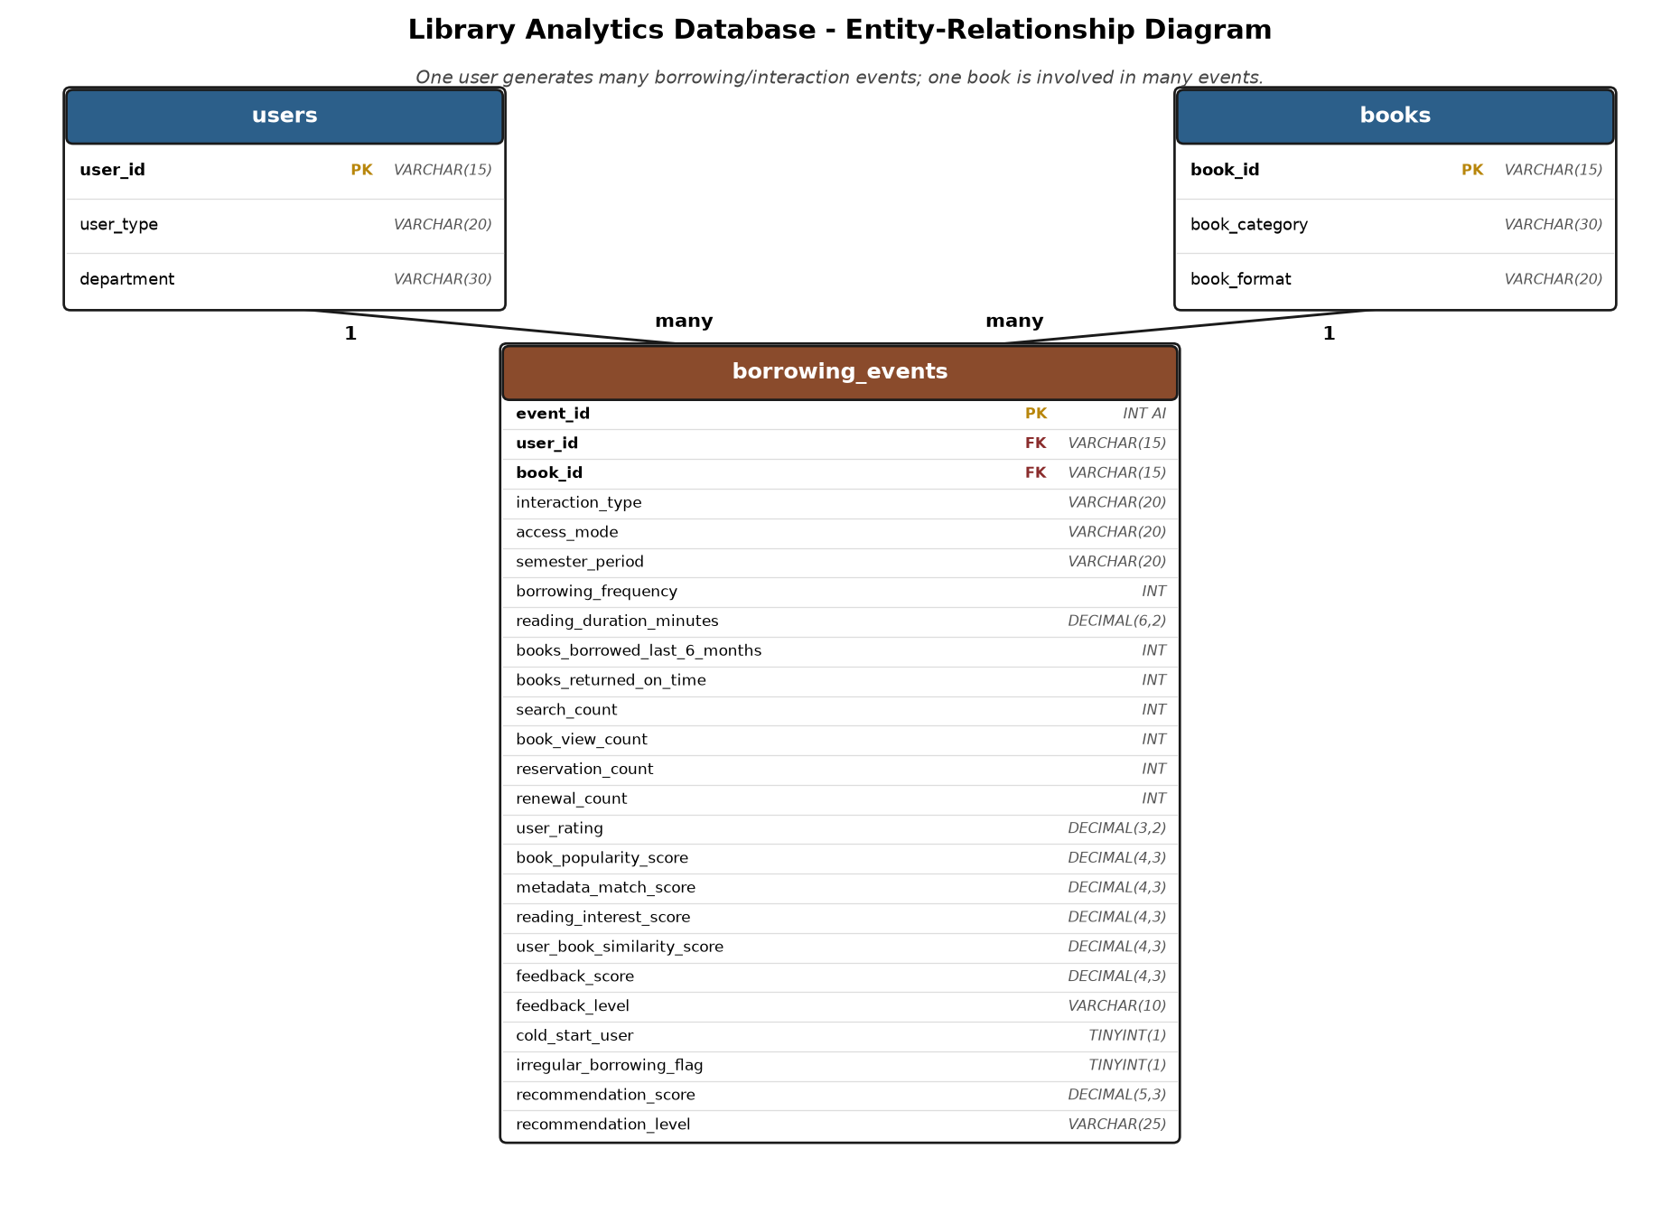
Figure 1. Entity-relationship diagram of the library_analytics_db database

4.2 SQL Query Results
Eight queries (SQL/checkpoint1_queries.sql) cover SELECT with WHERE/ORDER BY, GROUP BY with aggregates, multi-table JOINs, and queries that answer the business questions directly.
Table 3. Summary of the eight SQL queries and their business meaning
# | Query purpose | Key result | Business meaning
1 | Top 10 borrowers flagged irregular (WHERE, ORDER BY) | Several irregular-flagged patrons sit at the maximum frequency of 45 | High frequency does not guarantee regular borrowing; worth manual review
2 | Longest reading sessions among Borrowed events | Sessions of 150–180 minutes | Identifies the most invested readers
3 | Recommendation score, cold-start vs established (GROUP BY) | 0.478 vs 0.574; search count 40.3 vs 40.4 | Same effort, lower score for new patrons
4 | Borrowing frequency by feedback level (GROUP BY) | 19.3 / 18.9 / 19.5 for High / Low / Medium | Satisfaction is unrelated to borrowing intensity
5 | Engagement by book category (JOIN) | AI (15.3) and Data Science (15.1) lead; Law lowest (13.8) | Small differences; modest acquisition signal
6 | Irregular rate by department (JOIN) | Medicine 17.1%, Computer Science 16.7%, Science 14.9% | Narrow spread; not statistically significant
7 | Borrows by book format (BQ2) | 594–617 per format | Format is not a demand differentiator
8 | Cold-start vs established patrons (BQ3) | 18.5% of events; rating 2.99 vs 2.99; score 0.478 vs 0.574 | Equal satisfaction, lower recommendation quality

Interpretation. The SQL layer answers all three business questions descriptively. For BQ1, irregular borrowing is spread almost evenly (a chi-square test across departments gives p = 0.81, and across patron types p = 0.96). For BQ2, format makes no difference and category differences are small (an ANOVA on 6-month borrowing across categories gives p = 0.04, a weak effect). For BQ3, new patrons are clearly served worse.

5. Statistical Analysis

5.1 Descriptive Statistics
Table 4. Descriptive statistics for three key variables (n = 12,000)
Statistic | Borrowing Frequency | Reading Duration (min) | Recommendation Score
Mean | 19.227 | 94.288 | 0.556
Median | 18.00 | 94.87 | 0.557
Std. deviation | 14.086 | 49.989 | 0.107
Variance | 198.413 | 2,498.911 | 0.011
Minimum | 1.00 | 8.03 | 0.169
Maximum | 45.00 | 179.98 | 0.916
Range | 44.00 | 171.95 | 0.747

Borrowing frequency is right-skewed: 35.2% of events fall in the lowest bin (1–9) and the mode is 1, but 11.0% reach 40–45, so the library serves many light borrowers alongside a core of heavy ones. Reading duration (mean 94.3, median 94.9) and recommendation score (mean 0.556, median 0.557) are roughly symmetric with wide and moderate spread, respectively.
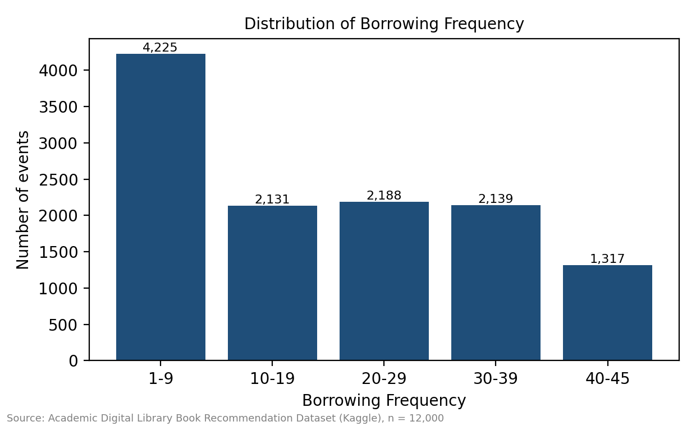
Figure 2. Frequency distribution of Borrowing Frequency

5.2 Correlation
Borrowing Frequency and Recommendation Score are moderately positively correlated (r = 0.506, r² = 0.256). Books Borrowed (last 6 months) and Books Returned On Time are also moderately correlated (r = 0.501); because these are raw counts from a synthetic file, we interpret this only as a relationship between counts, not a return rate.

5.3 Simple Linear Regression
Equation: Recommendation Score = 0.4823 + 0.003837 × Borrowing Frequency. R² = 0.256, and the slope is highly significant (p < 0.001). A patron who borrows 10 times is predicted to score 0.52, and one who borrows 30 times is predicted to score 0.60. Because borrowing frequency explains only about a quarter of the variation, Section 7 extends the model to multiple predictors. Task 2.5 (time-series forecasting) was not applicable because the dataset has no dates; average borrowing frequency differs by less than 0.35 across the three semester periods.
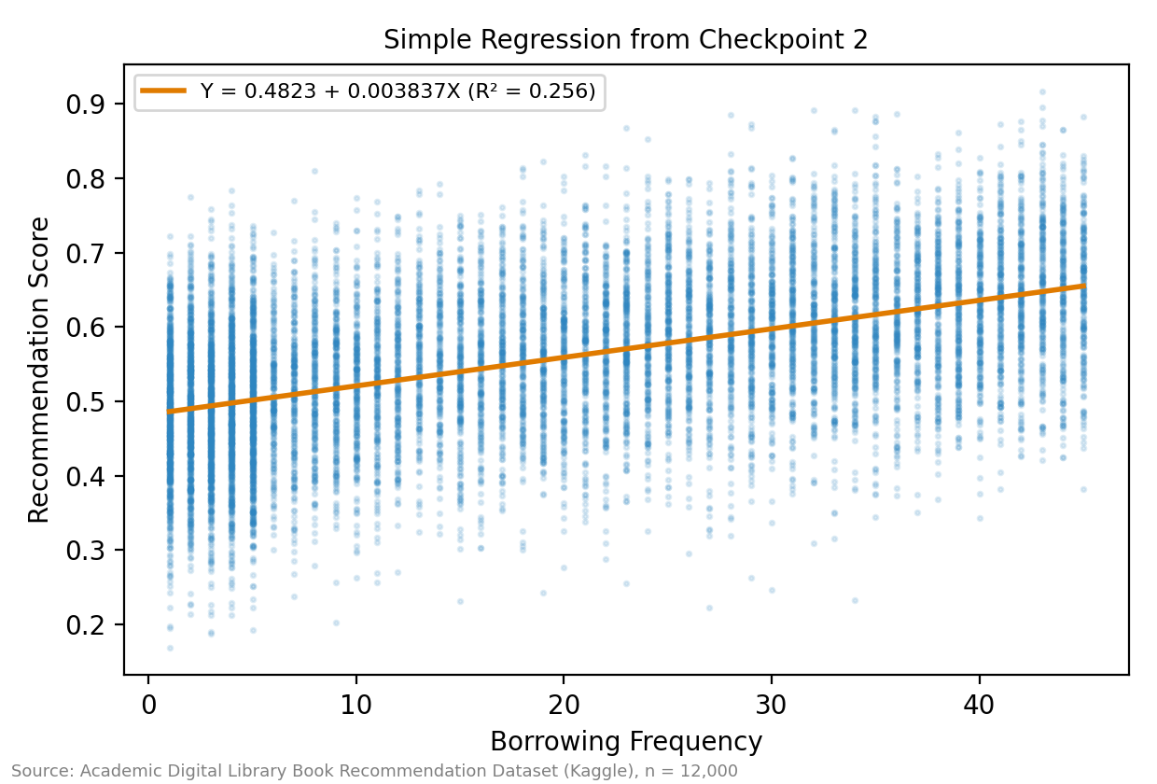
Figure 3. Simple regression of Recommendation Score on Borrowing Frequency (Checkpoint 2)

6. BI Dashboard Summary
The Power BI dashboard (PowerBI/LIBRARY_ANALYTICS_DASHBOARD.pbix, 1280 × 720) has three pages linked by page-navigation buttons. Four dropdown slicers (User Type, Department, Semester Period, Segment) are synchronized across all pages, and every visual cross-filters when clicked. Seven DAX measures drive the KPIs. All values reconcile to the SQL and Excel results: 12,000 patrons, 0.556 average recommendation score, 16.1% irregular rate, 18.5% cold-start share and 94.3 minutes average reading duration.

6.1 Page 1 — Executive Summary
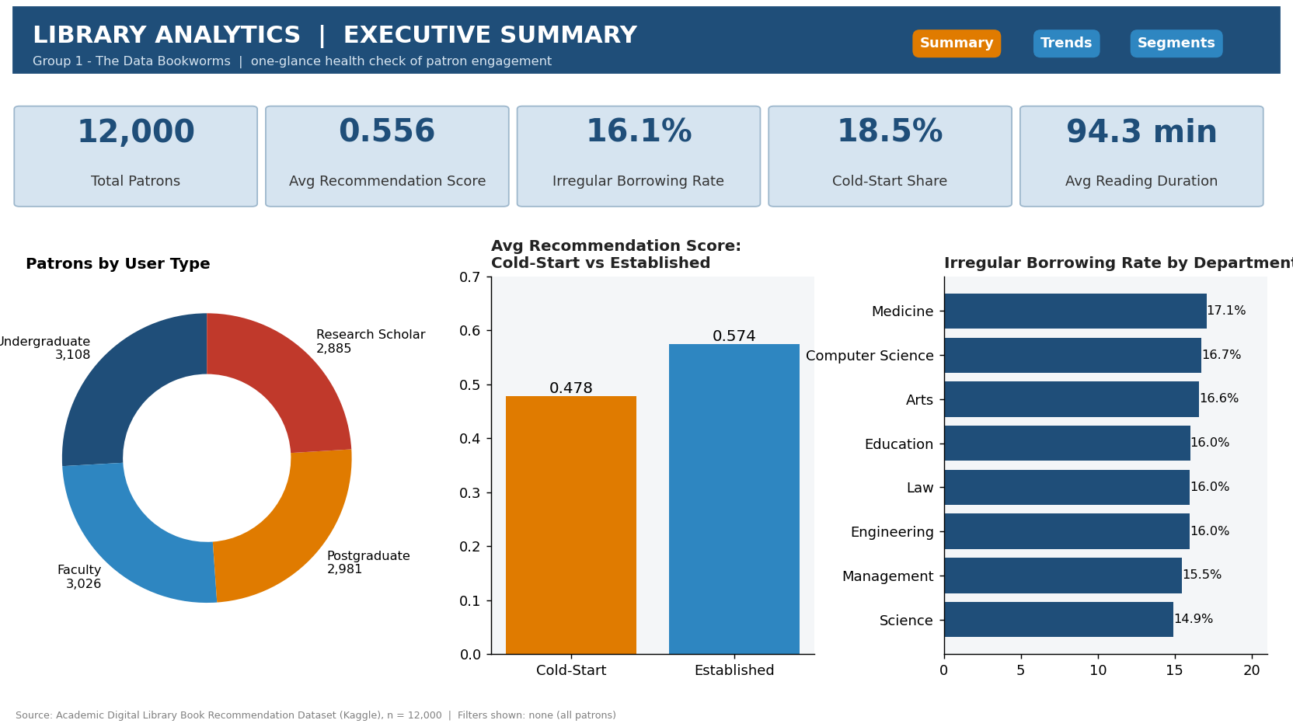
Figure 4. Dashboard Page 1: KPI cards, patrons by user type, score by patron status, irregular rate by department
Page 1 gives a one-glance health check. The cold-start versus established chart makes the BQ3 gap visible immediately (0.478 versus 0.574), and the department bar shows the narrow 14.9%–17.1% irregular-rate spread.

6.2 Page 2 — Trend and Comparison Analysis
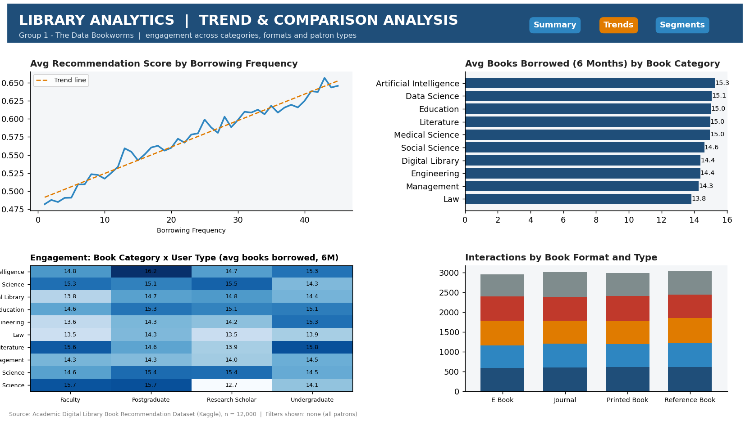
Figure 5. Dashboard Page 2: score by borrowing frequency, category comparison, category × user type matrix, format mix
Page 2 shows recommendation score rising steadily with borrowing frequency, nearly flat engagement across categories, and an even format and interaction mix, which supports the finding that format and patron type are not demand drivers.

6.3 Page 3 — Segmentation Deep Dive
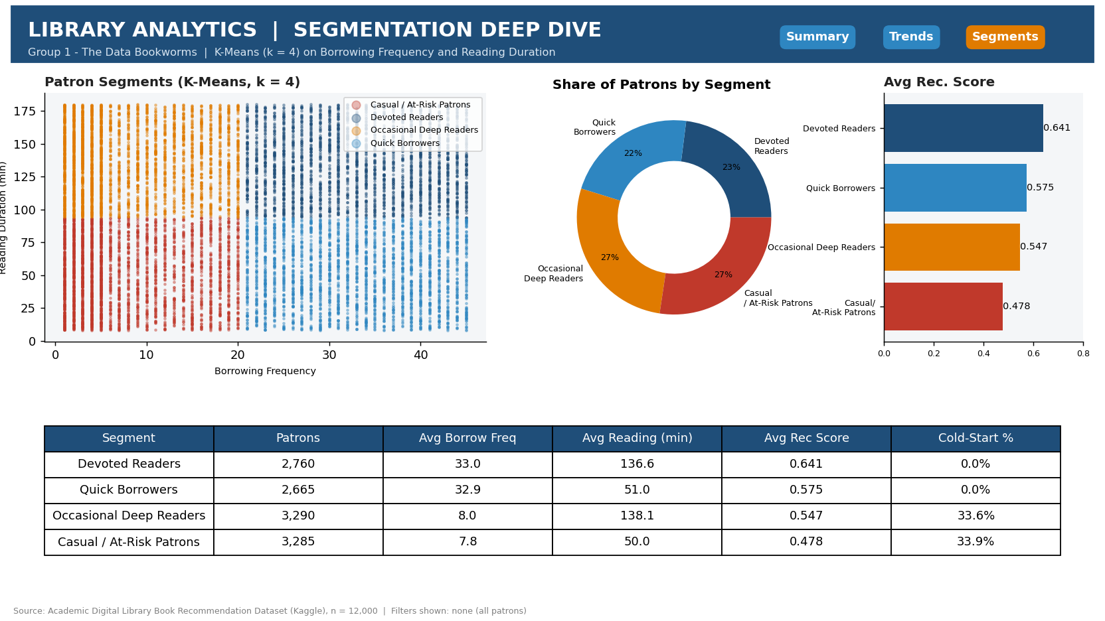
Figure 6. Dashboard Page 3: K-Means segments, segment share, segment recommendation score and profile table

6.4 Segmentation Findings
K-Means (k = 4, chosen using the elbow and silhouette charts) on standardized Borrowing Frequency and Reading Duration produced four named segments.
Table 5. Patron segment profiles
Segment | Patrons | Avg borrow freq | Avg reading (min) | Avg rec. score | Cold-start %
Devoted Readers | 2,760 (23%) | 33.0 | 136.6 | 0.641 | 0.0%
Quick Borrowers | 2,665 (22%) | 32.9 | 51.0 | 0.575 | 0.0%
Occasional Deep Readers | 3,290 (27%) | 8.0 | 138.1 | 0.547 | 33.6%
Casual / At-Risk Patrons | 3,285 (27%) | 7.8 | 50.0 | 0.478 | 33.9%

- Devoted Readers: borrow often and read long; best recommendation scores (0.641). Retain and use as ambassadors.
- Quick Borrowers: borrow often but read briefly (51 min). The opportunity is deeper engagement through better-matched titles.
- Occasional Deep Readers: read long (138 min) but borrow rarely (8). They are engaged but under-circulated; a third are cold-start.
- Casual / At-Risk Patrons: low borrowing and short reading, lowest score (0.478). They are the main onboarding and retention target.
Because the two features are close to uniformly distributed, the segments are a practical way to group patrons rather than naturally separated clusters; we use them for targeting, not as proof of distinct patron “types”.

7. Predictive Analytics

7.1 Approach
Building on the simple regression, we applied two techniques (Python, pandas / scikit-learn / statsmodels, per the guide's allowance for approved Python use; script: Python/checkpoint4_predictive.py). Data were split 70% training (8,400 rows) and 30% test (3,600 rows) with a fixed random seed, so all performance figures below come from data the model never saw.
- Model A — Multiple linear regression. Output (Y): Recommendation Score (0–1). Predictors (13): Borrowing Frequency, Reading Duration, Reading Interest Score, Metadata Match Score, User–Book Similarity, Book Popularity, Renewal Count, Book View Count, Reservation Count, User Rating, Books Borrowed (6 months), Search Count and the Cold-Start flag.
- Model B — Logistic regression. Output: whether an event receives a Low Recommendation (score below 0.45; 16.2% of events). Used as an early-warning classifier.

7.2 Model A Results
Table 6. Multiple regression coefficients (training set), sorted by standardized importance
Predictor | Coefficient (b) | Std. beta | p-value
Borrowing Frequency | 0.00353 | 0.463 | < 0.001
Reading Duration Minutes | 0.00073 | 0.338 | < 0.001
Book View Count | 0.00093 | 0.299 | < 0.001
Renewal Count | 0.00666 | 0.285 | < 0.001
Metadata Match Score | 0.10891 | 0.262 | < 0.001
User Rating | 0.02439 | 0.260 | < 0.001
Reservation Count | 0.00455 | 0.258 | < 0.001
Book Popularity Score | 0.10019 | 0.244 | < 0.001
Reading Interest Score | 0.09034 | 0.218 | < 0.001
User Book Similarity Score | 0.08802 | 0.212 | < 0.001
Cold Start | 0.00029 | 0.001 | 0.813
Books Borrowed Last 6 Months | 0.00001 | 0.001 | 0.814
Search Count | -0.00000 | -0.000 | 0.959

Table 7. Model A performance
Metric | Value
R² (training) | 0.918
Adjusted R² (training) | 0.918
R² (test set) | 0.914
RMSE (test) | 0.031 score points
MAE (test) | 0.022 score points
Compared with Checkpoint 2 simple model | R² improves from 0.256 to 0.914

The model explains about 91% of the variation in recommendation score on unseen data, with a typical error of about 0.02 on a 0–1 scale. Ten of the 13 predictors are highly significant. Books Borrowed (6 months), Search Count and the Cold-Start flag are not significant (p > 0.8). Borrowing Frequency is the strongest predictor (standardized beta 0.46), followed by Reading Duration (0.34), Book View Count (0.30) and Renewal Count (0.29). Multicollinearity is not a concern (largest VIF ≈ 2.0).
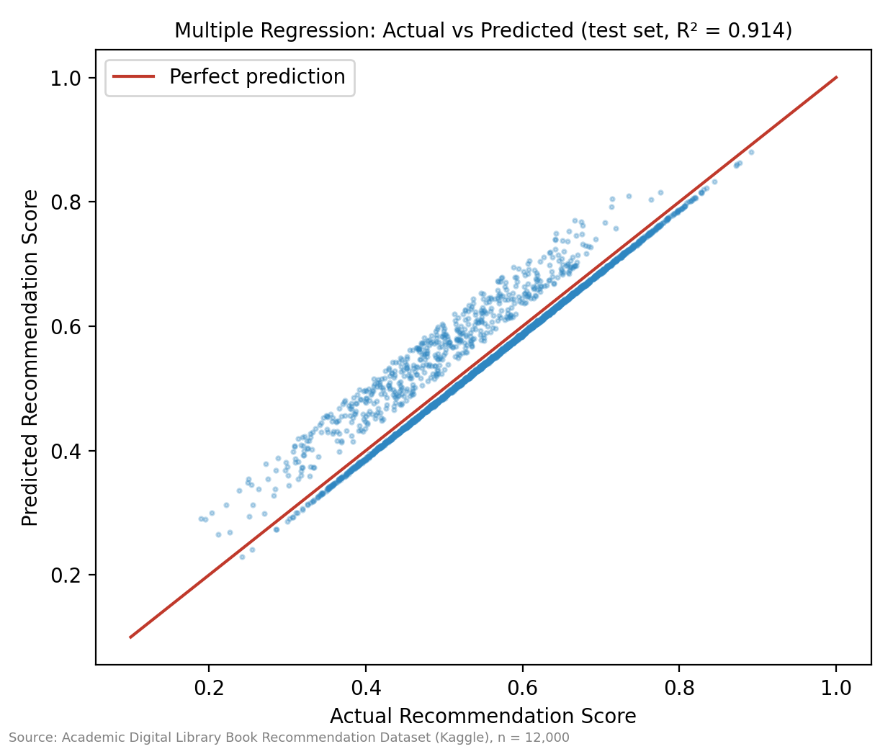
Figure 7. Actual versus predicted Recommendation Score on the held-out test set
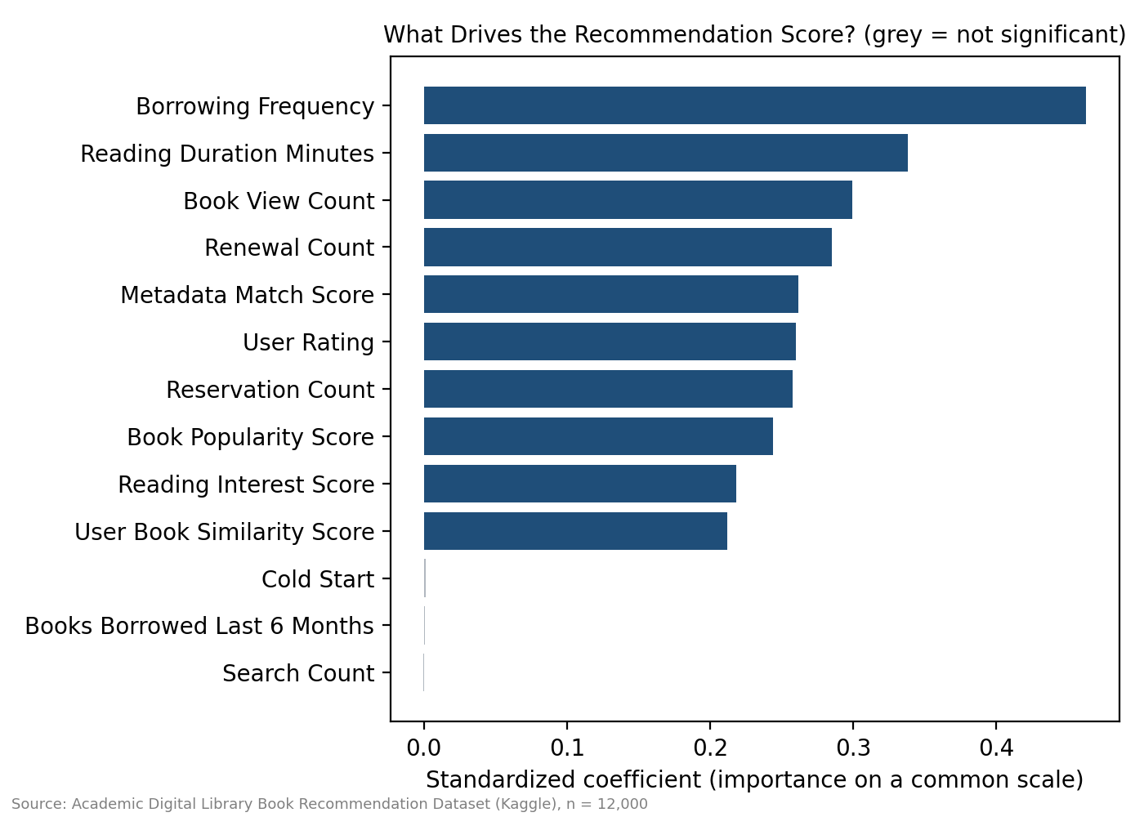
Figure 8. Standardized predictor importance in the multiple regression

7.3 Predictions from the Model
Table 8. What-if predictions (all other inputs held at their averages)
Scenario | Predicted score | Change
Average patron (baseline) | 0.556 | —
+5 borrowing frequency | 0.574 | +0.018
+30 minutes average reading duration | 0.578 | +0.022
+2 renewals | 0.569 | +0.013
+0.10 metadata match | 0.567 | +0.011
Typical new patron (3 borrows, cold-start) | 0.499 | -0.057
Typical established patron (23 borrows) | 0.569 | +0.013

7.4 Model B Results (Logistic Regression)
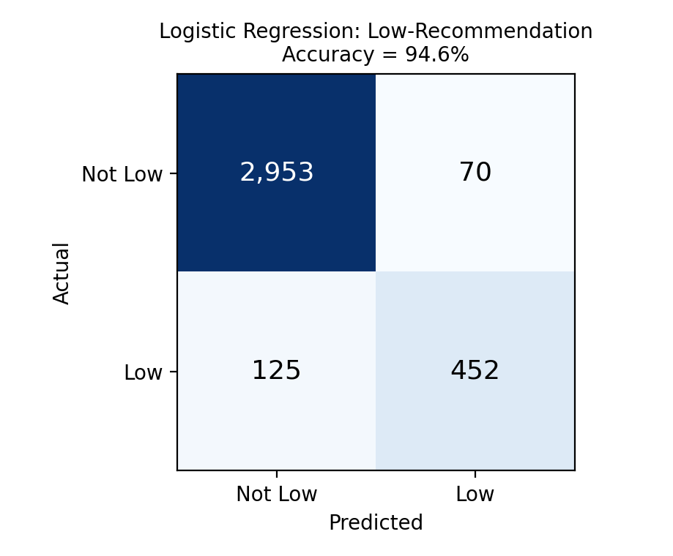
Figure 9. Confusion matrix for predicting Low Recommendation (test set)
On the test set the classifier reaches 94.6% accuracy against 84.0% for always predicting “not low”. Precision is 86.6% (of patrons flagged low, that share truly are) and recall is 78.3% (of all truly low cases, that share are caught): 452 of 577 low cases were found with 70 false alarms.

7.5 Business Predictions and Actionable Recommendations
- Prediction 1 — New patrons will keep receiving weaker recommendations until they build history. A typical new patron is predicted at 0.50 versus 0.57 for an established one (a gap of about 0.07). Because the cold-start flag is not significant once borrowing frequency is known, helping new patrons borrow earlier should close most of the gap.
- Prediction 2 — Each extra 5 borrows raises the expected score by about 0.018; 30 more minutes of reading adds about 0.022. Engagement programs (reading challenges, reminders) are the most powerful levers available to the library.
- Prediction 3 — About one in six events is expected to receive a Low Recommendation, and the classifier can identify roughly 78% of them. Running it on current patrons produces a priority outreach list before patrons become disengaged.
- Prediction 4 — Improving metadata and patron interest data gives smaller but real gains: +0.10 in metadata match adds about 0.011, comparable to adding two renewals.

7.6 Assumptions, Limitations and Conditions
- Synthetic data. The recommendation score is produced by an algorithm, so an R² of 0.91 means we have largely reconstructed how the score is computed from its inputs. It is not evidence that these factors cause real patrons to behave a certain way.
- Association, not causation. The what-if predictions describe how the score changes in the data, not what will happen if the library changes patron behavior.
- Linear-model assumptions. The relationships are treated as linear and additive; the actual-versus-predicted plot shows a tight linear fit across the range, and no predictor pair is strongly collinear. Residual normality was not formally tested.
- Scope. Predictions are valid only within observed ranges (e.g., Borrowing Frequency 1–45) and for this library's patron mix. There is no time dimension, so the model cannot forecast future trends.
- Class imbalance. Low Recommendation is only 16% of events, so accuracy alone flatters the classifier; we therefore report precision and recall as well.

8. Ethics and Governance

8.1 Privacy Considerations
The dataset contains no names, contact details, student numbers or other direct identifiers. Each patron is represented by a pseudonymous code (e.g., USR_10001), and the attributes recorded are patron type, department, and behavioral measures such as borrowing frequency, reading duration, searches and ratings. Although these fields look harmless, reading behavior is sensitive: what a person borrows and reads can reveal their interests, beliefs, health concerns or academic struggles, and librarianship has long treated reading records as confidential. Our data are synthetic, so no real person's reading history is exposed in this project. Had we used real circulation data, we would have needed written permission from the library, removal of direct identifiers, and aggregation so that small groups (for example, a single research scholar in one department) could not be re-identified.

8.2 Ethical Issues and Bias
First, the data are synthetic and almost perfectly balanced, so they cannot reveal real-world biases and could give a false impression that the library serves all groups fairly. Second, our central finding is itself a fairness issue: cold-start patrons receive recommendation scores about 17% lower despite equal effort and equal satisfaction. If a library used these scores to decide who receives promotions, purchase priority or staff attention, new students, often first-year undergraduates, would be systematically disadvantaged simply for being new. Third, the segments and the irregular-borrowing flag could be misused to label individuals, for example treating “Casual / At-Risk Patrons” as unmotivated or penalizing “irregular” borrowers, when low borrowing may reflect limited time, part-time work, or access problems. We therefore use segments only to design supportive services, never to restrict access, impose fines, or evaluate individual students or faculty. Fourth, the classification model has errors: in our test, 125 genuinely low-recommendation cases were missed and 70 patrons were flagged incorrectly, so no decision about a person should rest on the model alone without human review.

8.3 Data Governance
The dataset is published on Kaggle under its own terms and is used here only for coursework; the group does not own it. In a real deployment the library, as the data controller, would own the circulation data and be accountable for it, with the institution's Data Protection Officer overseeing its use. A responsible governance framework for this dataset would include: (1) a clear, documented purpose limited to improving library services; (2) data minimization, collecting only fields needed for that purpose; (3) role-based access, with analysts seeing pseudonymized data only; (4) retention limits, deleting event-level records after a set period; (5) a documented model-review process that checks recommendation quality across patron groups (such as cold-start versus established) at least each semester; (6) transparency, so patrons are told that their activity informs recommendations and can opt out of profiling; and (7) an incident-response procedure for any data breach.

8.4 Regulatory Awareness
In the Philippines, the Data Privacy Act of 2012 (Republic Act No. 10173) governs personal information. Its principles of transparency, legitimate purpose and proportionality apply directly: patrons must be informed how their reading data is processed, the processing must serve a declared and legitimate purpose, and only data necessary for that purpose may be used. The Act also gives data subjects rights of access and correction, and requires organizations to protect personal data and report serious breaches to the National Privacy Commission. The European Union's General Data Protection Regulation (GDPR) offers a similar conceptual benchmark, notably data minimization, purpose limitation, and the right not to be subject to solely automated decisions with significant effects, which supports our position that model outputs should inform, not replace, human decisions. Because our data are synthetic and contain no identifiable persons, RA 10173 does not restrict this project, but we designed our methods and recommendations to comply with it should the library apply them to real data.

9. Conclusions and Recommendations

9.1 Conclusions
Returning to the three business questions:
- BQ1 (irregular borrowing): About 16% of events are flagged irregular in every patron type and department. Medicine and Computer Science are highest, but the differences are too small to be statistically meaningful, so irregular borrowing is a library-wide behavior.
- BQ2 (engagement): Book format and patron type make little difference. Artificial Intelligence and Data Science have slightly higher recent borrowing, but the overall engagement pattern is balanced. Differences in individual behavior (borrowing frequency and reading duration) matter far more than differences in what is borrowed.
- BQ3 (cold-start patrons): New patrons are underserved (0.478 versus 0.574), and the multiple regression shows why: their score is lower because they have little borrowing history, not because of the cold-start label itself. The gap can therefore be narrowed by helping new patrons engage sooner.

9.2 Recommendations
Table 9. Recommended actions, supporting evidence and expected effect
# | Recommendation | Evidence | Expected effect
1 | Launch a fast-start onboarding path: guided first-loan lists, a short interest profile at sign-up, and a prompt after the first borrow | Cold-start score 0.478 vs 0.574; cold-start flag not significant after borrowing frequency; new patrons average 3 borrows | Closes most of the ~0.07 score gap by speeding up history building
2 | Run segment-specific nudges: loan reminders for Occasional Deep Readers; “read next” lists for Quick Borrowers; check-ins for Casual / At-Risk Patrons | Segments differ in borrow frequency, reading time and score (0.478–0.641) | Each +5 borrows lifts expected score by ~0.018; 30 more minutes reading by ~0.022
3 | Apply irregular-borrowing reminders and outreach library-wide, not department by department | Department rates 14.9%–17.1%, chi-square p = 0.81 | Avoids wasting effort on differences that are not real
4 | Improve book metadata quality and collect richer patron interests | Metadata match, interest and similarity are significant predictors | Gradual score gains (+0.10 metadata ≈ +0.011)
5 | Use the Low-Recommendation classifier as a weekly early-warning list for librarian follow-up, with human review | 94.6% accuracy, 78% recall | Reaches at-risk patrons before they disengage

Collection note: because category and format demand are nearly even, the library should not shift acquisition budgets sharply toward any one category or format on the strength of this data; a small priority for Artificial Intelligence and Data Science titles is the most the evidence supports.

9.3 Limitations and Future Work
All findings should be validated with the library's real circulation records, ideally with dates so that true trends and seasonality (Task 2.5) can be analyzed. With real data, a decision-tree or gradient-boosting model, patron-level longitudinal tracking and a fairness audit by patron group would be natural next steps, and a pilot of the onboarding path could measure whether new patrons' recommendation quality actually improves.

10. References
Colabsss. (n.d.). Academic digital library book recommendation dataset [Data set]. Kaggle. https://www.kaggle.com/datasets/colabsss/academic-library-book-recommendation-data
Hunter, J. D. (2007). Matplotlib: A 2D graphics environment. Computing in Science & Engineering, 9(3), 90–95. https://doi.org/10.1109/MCSE.2007.55
MacQueen, J. (1967). Some methods for classification and analysis of multivariate observations. In Proceedings of the Fifth Berkeley Symposium on Mathematical Statistics and Probability (Vol. 1, pp. 281–297). University of California Press.
McKinney, W. (2010). Data structures for statistical computing in Python. In Proceedings of the 9th Python in Science Conference (pp. 56–61). https://doi.org/10.25080/Majora-92bf1922-00a
Microsoft. (2026). Power BI Desktop [Computer software]. Microsoft Corporation. https://powerbi.microsoft.com
Microsoft. (2026). Microsoft Excel [Computer software]. Microsoft Corporation.
Oracle. (2026). MySQL [Computer software]. Oracle Corporation. https://www.mysql.com
Pedregosa, F., Varoquaux, G., Gramfort, A., Michel, V., Thirion, B., Grisel, O., … Duchesne, É. (2011). Scikit-learn: Machine learning in Python. Journal of Machine Learning Research, 12, 2825–2830.
Republic Act No. 10173. (2012). Data Privacy Act of 2012. Republic of the Philippines. https://www.privacy.gov.ph/data-privacy-act/
Regulation (EU) 2016/679 of the European Parliament and of the Council of 27 April 2016 (General Data Protection Regulation). (2016). Official Journal of the European Union, L 119, 1–88.
Ricci, F., Rokach, L., & Shapira, B. (Eds.). (2015). Recommender systems handbook (2nd ed.). Springer. https://doi.org/10.1007/978-1-4899-7637-6
Rousseeuw, P. J. (1987). Silhouettes: A graphical aid to the interpretation and validation of cluster analysis. Journal of Computational and Applied Mathematics, 20, 53–65. https://doi.org/10.1016/0377-0427(87)90125-7
Seabold, S., & Perktold, J. (2010). Statsmodels: Econometric and statistical modeling with Python. In Proceedings of the 9th Python in Science Conference (pp. 92–96). https://doi.org/10.25080/Majora-92bf1922-011

11. Appendix

Appendix A — Raw Data Sample (first 10 rows)
Table 10. Raw dataset preview (selected 9 of 28 columns)
User ID | Book ID | User Type | Department | Book Category | Interaction Type | Borrowing Frequency | Recommendation Score | Cold Start User
USR 10001 | BK 50001 | Research Scholar | Medicine | Education | Reviewed | 3 | 0.366 | Yes
USR 10002 | BK 50002 | Faculty | Law | Digital Library | Viewed | 3 | 0.518 | No
USR 10003 | BK 50003 | Faculty | Education | Digital Library | Borrowed | 40 | 0.747 | No
USR 10004 | BK 50004 | Undergraduate | Law | Data Science | Reviewed | 25 | 0.48 | No
USR 10005 | BK 50005 | Undergraduate | Medicine | Literature | Viewed | 23 | 0.535 | No
USR 10006 | BK 50006 | Research Scholar | Education | Literature | Viewed | 37 | 0.7 | No
USR 10007 | BK 50007 | Faculty | Science | Social Science | Viewed | 1 | 0.398 | Yes
USR 10008 | BK 50008 | Undergraduate | Management | Management | Reserved | 37 | 0.598 | No
USR 10009 | BK 50009 | Research Scholar | Computer Science | Engineering | Reviewed | 6 | 0.483 | No
USR 10010 | BK 50010 | Undergraduate | Law | Literature | Borrowed | 25 | 0.633 | No

Appendix B — Individual Contribution Forms (Checkpoint 4)
Individual Contribution Form — BED 106 Capstone Project
Group: Group 1 — The Data Bookworms Checkpoint No.: 4
Member Name: Peter Paul Polestico Role: Project Lead / Analyst
Specific Contributions This Checkpoint:
1. Refined the business problem and scope across all sections
2. Integrated the four checkpoints into the final report and wrote the executive summary
3. Led the ethics and governance reflection and the final recommendations
I certify that the contributions listed above are accurate and reflect my actual participation.
Signature: ____________________ Date: ____________________

Individual Contribution Form — BED 106 Capstone Project
Group: Group 1 — The Data Bookworms Checkpoint No.: 4
Member Name: Ken T. Lubrico Role: Data Engineer
Specific Contributions This Checkpoint:
1. Maintained the final database design, cleaned data and SQL queries
2. Prepared the SQL and data-source sections of the final report
3. Verified that dashboard and statistical figures reconcile to the database
I certify that the contributions listed above are accurate and reflect my actual participation.
Signature: ____________________ Date: ____________________

Individual Contribution Form — BED 106 Capstone Project
Group: Group 1 — The Data Bookworms Checkpoint No.: 4
Member Name: Johnro Balingit Role: Statistician / Modeler and BI Developer / Visualizer
Specific Contributions This Checkpoint:
1. Built and evaluated the multiple regression and logistic regression models
2. Maintained the Power BI dashboard and segmentation
3. Prepared the statistical, dashboard and predictive sections of the final report
I certify that the contributions listed above are accurate and reflect my actual participation.
Signature: ____________________ Date: ____________________

Appendix C — Peer Evaluation Forms
One signed peer evaluation form per member (Form B of the project guide) is submitted to the instructor in a sealed envelope on defense day, as required. The form used is reproduced below.
Member name | Effort /5 | Quality /5 | Collab. /5 | Commun. /5 | Comments
______________
______________
______________
Evaluator's Name: ______________________ Group: Group 1 — The Data Bookworms Signature: ______________ Date: ________

Appendix D — Digital Files Index
Table 11. Project files submitted with this report
Folder / file | Contents
SQL/library_db_setup.sql, SQL/checkpoint1_queries.sql | Database schema, data load, and the eight queries (Checkpoint 1)
Excel/Checkpoint2_Spreadsheet_Analytics.xlsx | Pivot analysis, charts, formulas, statistics, correlation, regression (Checkpoint 2)
PowerBI/LIBRARY_ANALYTICS_DASHBOARD.pbix | Three-page interactive dashboard (Checkpoint 3)
Python/checkpoint3_clustering.py | K-Means segmentation
Python/checkpoint4_predictive.py | Multiple and logistic regression models (Checkpoint 4)
data/ | Source dataset, Power BI dataset, segment and model output files
docs/ | Checkpoint reports, this final report and the presentation script

